ChassisSim Setup Sweep Options

Introduction the Purpose of this document is to outline the setup sweep options as they exist in ChassisSim v3.31. The engine for this will be the ChassisSim scripting but it will be run internally in ChassisSim.

User Interface in ChassisSim

The user interface in ChassisSim is illustrated below,

There are two components,
- Setup options – contains what you want to sweep through.
- Data logging settings – sets the components for each sweep.

Both files are ascii Tab delimited files. Note the base car file will be the currently loaded car file in ChassisSim. The base circuit will be what is defined. Please ensure a valid circuit path is specified or this feature will not execute.

Also please note in both the Setup Options File and Batch File please remove comments with “ or ‘ characters.

Setup Options file

The setup options file is simply a list of components that you want to try. This is being done in this format to make it as flexible as possible. You can either make it simple or very complex. An example of this with commentary is shown below,

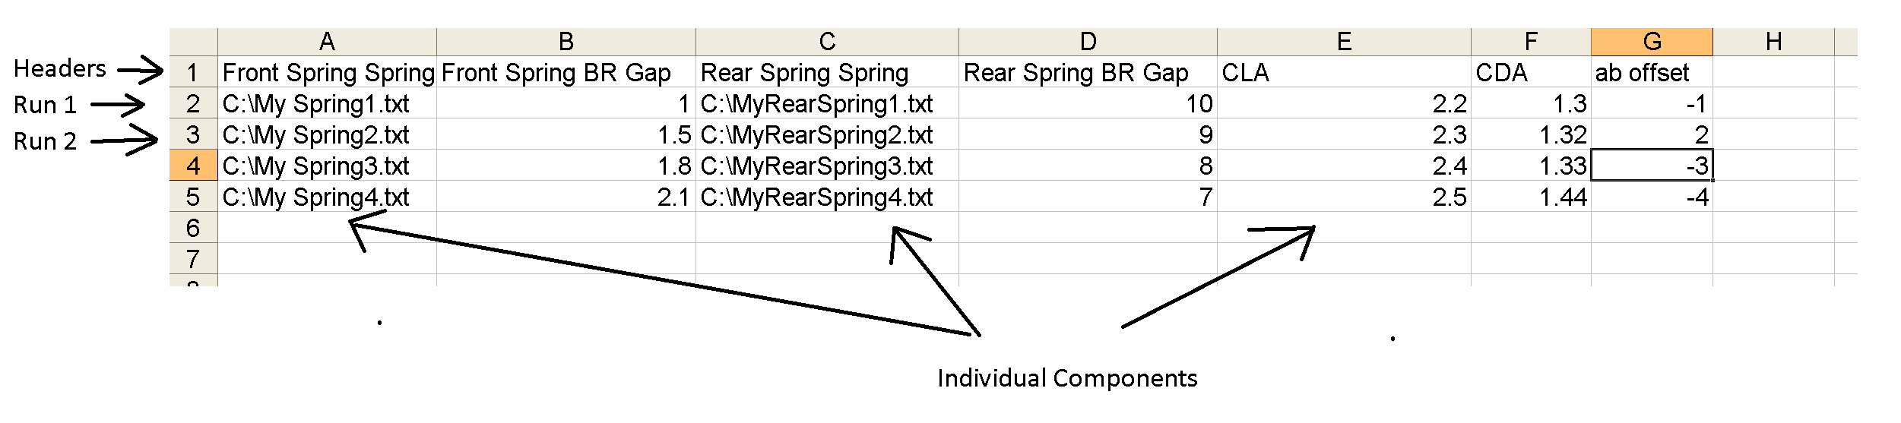
While this has been illustrated in excel it will be saved as a text tab delimited file. The first row will tell ChassisSim what components are being investigated. The second row till the end will determine what is being swept through. The number of this will determine the no of setup runs. A full definition of all the setup names is provided in the appendix.

Note this format is being adopted to ensure maximum flexibility.

Data logging options platform

The data logging options platform is done in a similar manner. This is illustrated below,

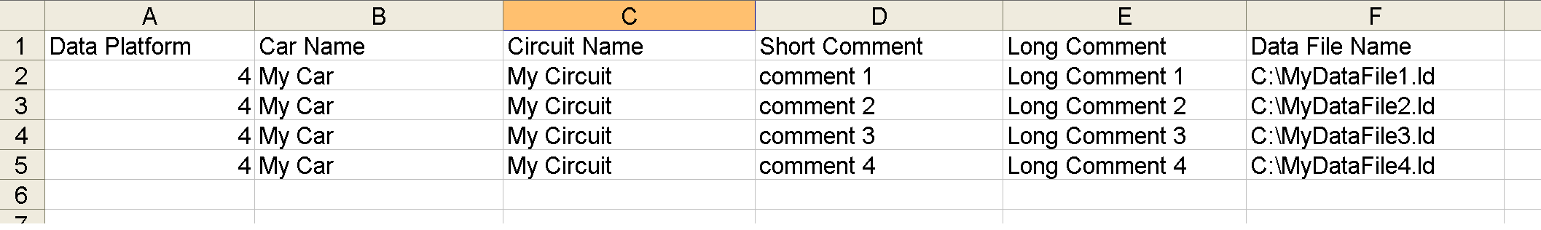

The first column is the data platform and has the same convention as Simulate->Data logging options. The second and third columns are the car and circuit names. The third and fourth columns are the short and long comments. The last column is the data file names. The definition of each column is summarised below,

Item | Definition
Data Platform | The Data platform. An integer between 1- 11
Car Name | Name of the car
Circuit Name | Name of the circuit
Short comment | The short data comment
Long comment | The long data comment
Data File Name | This is the data file name

Please note this is saved as a text tab delimited file.

A Note on file definitions

Note when specifying a file specify the full path. So if the file you want to use is in C:\ChassisSimTechnologies\Models\MyCar then you will enter C:\ChassisSimTechnologies\Models\MyCar\my car component.txt

Setup Options file definition

The setup file options definitions and headers are outlined in the table below. However for ease of documentation the spring name definitions are,

Spring Name | Definition
Front Spring | Front Spring covers both left and right spring
FL Spring | Front Left Spring
FR Spring | Front Right Spring
FTHS Spring | This is the front third spring/monoshock
Rear Spring | Rear spring – this covers both the left and right
RL Spring | Rear Left spring
RR Spring | Rear Right spring
RTHS Spring | Rear third spring

The geometry definitions are

Geometry Name | Definition
Front Geometry | This is the front left and right geometry
FL Geometry | This the front left geometry
FR Geometry | This is the front right geometry
Rear Geometry | This is the rear geometry
RL Geometry | This the rear left geometry
RR Geometry | This is the rear right geometry

The tyre definitions are

Tyre Name | Definition
Front Tyre | This is the front left and right tyre
FL Tyre | This the front left tyre
FR Tyre | This is the front right tyre
Rear Tyre | This is the rear tyre
RL Tyre | This the rear left tyre
RR Tyre | This is the rear right tyre

These are the full definitions

Name | Description
Front Spring Spring | Front Spring rate/Spring File
Front Spring Bi Linear | Front Spring Bi Linear spring file
Front Spring BR Gap | Front Spring BR Gap
Front Spring BR Gnd Gap flg | Front Spring BR Gnd gap flag
Front Spring BR File | Front Spring BR file/spring rate
Front Spring Damper File | Front Spring Damper file
Front Bar | Rate specified in N/m
Rear Bar | Rear bar rate specified in N/m
Front Tyre Camber | Front tyre camber
Front Tyre Toe | Front toe setting
Front Geometry Geom File | Front pickup points
Front Geometry MR File | Front Motion Ratio file
Gearbox GR File | Gear ratios
CLA | Global CLA
CDA | Global CDA
AB offset | Aero balance offset (%/100)
Air density | Air density in kg/m³
Downforce Lookup table | Downforce lookup table
Drag Lookup table | Drag lookup table
Aero balance Lookup table | Aero balance lookup table
Front RH | Front ride height
Rear RH | Rear ride height
Car Mass | Car mass in kg
Front weight distribution | Front weight distribution (%/100)
Engine File | Engine Torque map
Driveline efficiency | The driveline efficiency
Throttle dist map on | Indicates whether the throttle distance map is on
Throttle dist map | The throttle distance map.

Note when using this asymmetrically rather then specifying “Front Spring Spring” you would enter “FL Spring Spring”

